Norman Cornish - The Test of Time
By Mike Thornton
Mike Thornton spoke without notes for over an hour and gave a spell binding talk. Explaining the process and development of Cornish’s painting.
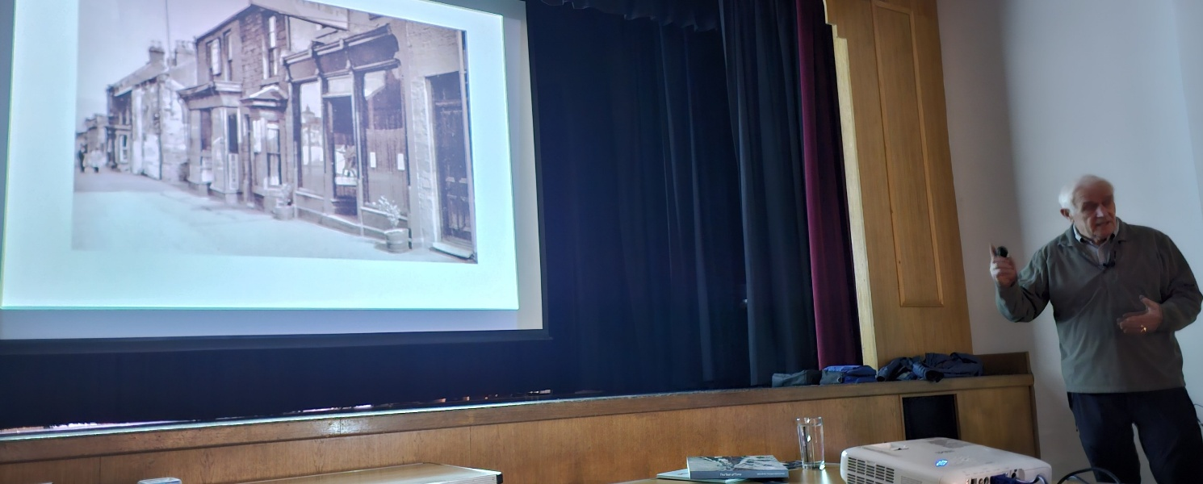
A self portrait
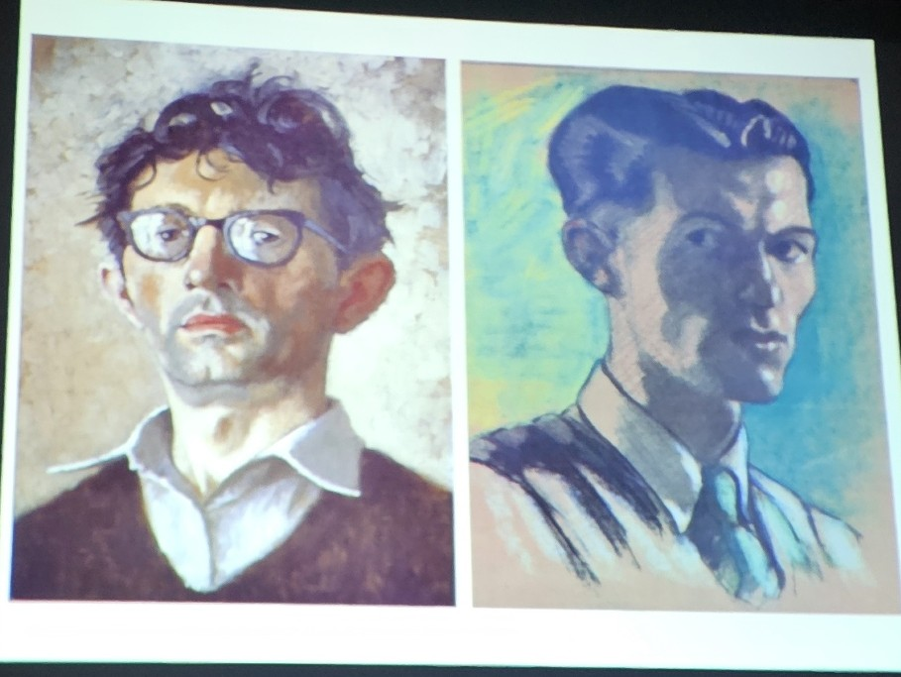
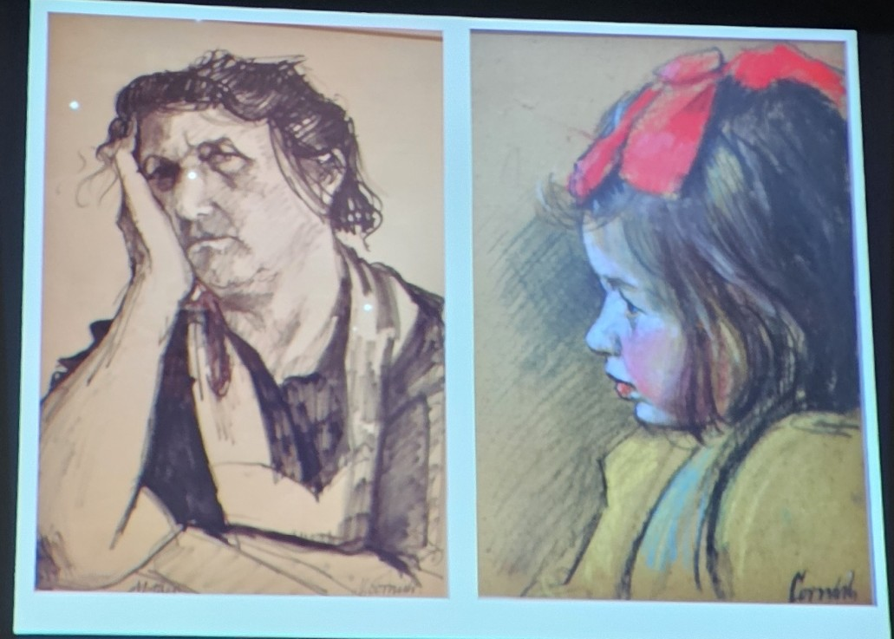
His mother and a neighbour’s child. Kept quiet during the sitting by watching black & white TV!

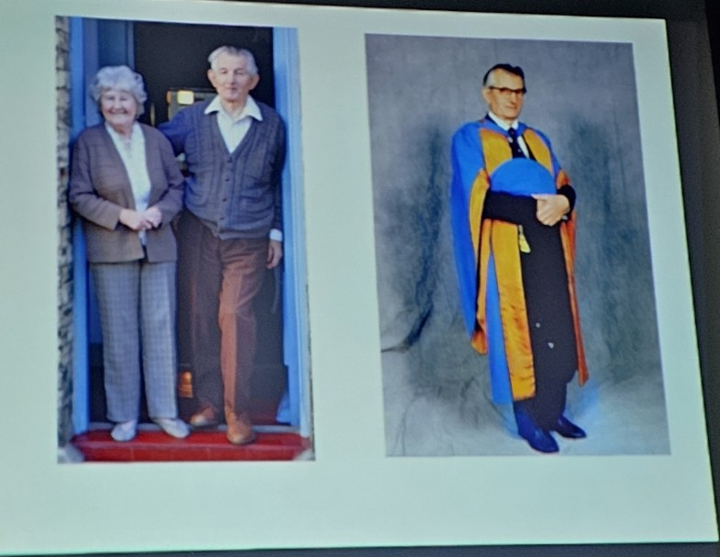
Awarded Honorary Doctorates from Newcastle & Sunderland Universities

