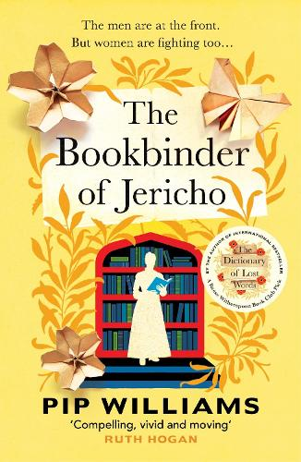
The Book Binder of Jericho
Pip Williams
This was our January book and what a fortuitous choice it turned out to be.
We gave it a score of 9 out of ten! We loved the book!
The book is a follow on to Dictionary of Lost Words and deals with similar themes of women’s lives.
Pip Williams’ description of the lives of the girls in the Clarendon Press is so effective. The repetition and patterning of the printed sheet gathering was mesmerising, whilst at the same time making clear the monotony of the task for the women.
Making the two main characters twins adds great depth to the narrative. Peggy has assumed that she must look after Maude. She left school early to do that. As she grows up and other people come into Maude’s life we get the hints of jealousy that carers often feel, being reluctant to lose their autnomy.
The informative aspect of the writing was detailed and thorough, with added social comment. The “bone folder” still exists!
What was so clearly evident all through the novel was the stratification of society “Town / Gown” ; “Men / Women”
What was also made clear was the resilience of people coping with the aftermath of war.
Our discussion was long and detailed and all the group loved the writing. However, Pip Williams descriptions of the horrendous conditions that many of the women had to cope with looking after war wounded and people suffering with the Spanish Flu, was in a way, brushed aside!
As always women had to do manage and then return to their roles in life!

